GBV mitigation during the COVID-19 pandemic

Oxfam IBIS and Oxfam in Liberia
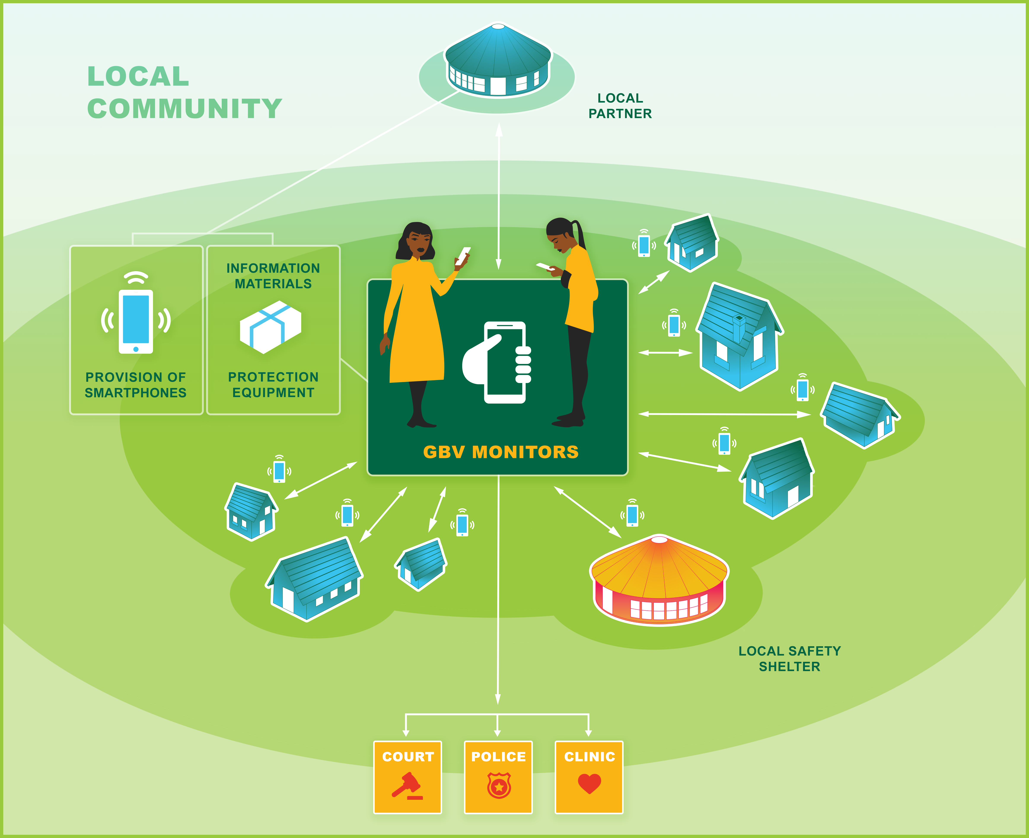Illustration: Yeray López Portillo

This mitigation guide includes the following:
- An explanation of the approach for community-based mitigation of gender-based violence (GBV) during the COVID-19 pandemic.
- A guide for implementing programmatic interventions addressing GBV.
- Standard Operating Procedures (SOPs), setting the ground rules for “GBV Case Monitoring and Management in the Context of the Coronavirus Outbreak” and “Reducing COVID-19 Transmission in Safe Homes, Local Safe Shelters and in Transit”.
- Annexes providing an “Induction to and Capacity Strengthening of GBV Monitors and Others”, a guide on how to handle “Assets/Inventory”, a guide on how to ensure “Accountability” and a format for setting up a “Phone Contact List”.
Globally, gender based violence, (GBV) – particularly domestic or family-based violence – are on the increase as many families are isolated or under lockdown for weeks in their homes. Women staying at home with abusive partners are at increased risk of being severely harmed due to increased financial pressure and other stressors associated with the outbreak. Aiming to respond to such increase in violence, this this document provides guidance for the prevention of gender-based violence and protection of survivors of GBV in the context of the coronavirus pandemic.While curbing the rise in GBV, interventions also include protection against the virus itself. With restriction in movement and curfew in many countries, existing GBV monitoring systems are no longer operational. To mitigate this situation, we are presenting a defined approach to support monitoring, mediation, counselling, interim safe spaces and safe homes – all operated by the single communities and supervised via phones.
With such interventions we aim to contribute not only by providing immediate support to victims but also to document the actual cases and collect data to ensure transparency and accountability for survivors of GBV.

Disclaimer: All reasonable precautions have been taken by Oxfam IBIS to use up-to-date information in this publication. However, given the novelty of the coronavirus, the recommendations herein may be subject to change, following the guidance of the World Health Organization and other health experts. The guidance in this publication should be used after considering the most up-to-date information available from health experts and periodically reviewed and updated as necessary.
In no event will Oxfam IBIS be liable for any damages including, without limitation, indirect or consequential damages, or any damages whatsoever arising from the use of or in connection with this guide, whether in contract or in negligence.
Introduction
As we are all aware, the COVID-19 pandemic has significant gendered implications. Gender-based violence (GBV) – or rather family-based violence – is a violation of human rights and is on the increase. In this guide, the term GBV encompasses all of the many forms that GBV takes, however, this guide focusses on domestic violence, which is being exacerbated during the COVID-19 pandemic. The present increase in domestic violence is a worldwide trend as many families are isolated or under lockdown for weeks in their homes. In developing countries, the situation is especially dire as so many men and women, who live hand to mouth, no longer earn enough to get by. Women staying at home with abusive partners are at increased risk of being severely harmed or even killed as their partners fail to manage the increased financial pressure and other stressors associated with the virus outbreak. This increased risk does not only affect women – children are equally affected.
Restrictions in movement to control the COVID-19 virus mean that programmes working to address GBV are unable to continue with business as usual. Measures and new ways of working need to be developed to protect survivors, monitor cases, prevent and respond to violence in communities, and avoid leaving vulnerable people more exposed than ever. Even where women and children might be able to leave their homes physically, the already weak system for dealing with GBV and child protection is further weakened as the authorities have left their posts. Therefore, even in a pandemic, community-based interventions to eliminate GBV must be accompanied by national-level strategic advocacy to counter the anticipated breakdown in the GBV referral pathways.

The GBV fast-track mitigation concept
To mitigate this situation, we have devised an approach and guidance to support (i) prevention, (ii) monitoring and mediation/counselling and (iii) interim safe spaces. It also includes Standard Operating Procedures (SOPs) to ensure that COVID19-related precautions and safety measures are fully met while running the activities.
Next, we describe an implementation guide to a community-based model that can work temporarily as protection for those facing sexual and gender-based violence.
Implementation guide
The approach presented in this guide address GBV prevention and response in light of COVID-19. To comply with precautions aimed at reducing the risk of transmission of the virus, GBV interventions must be conducted within the community and based on the competences already developed with local actors, such as active beneficiaries and those engaged in local community based organisations, CBOs and community groups. Hence often the various change agents already working within existing programmes as activities are generally restricted to a certain community. Any action must comply strictly with the required physical distancing of six feet or two meters, and involve handwashing and disinfection, face masks and any other required measures, as outlined in the SOPs included in this guidance. The success of this approach will, in large part, depend on the buy-in of community leaders. For instance, community leaders engaged through this approach must understand the importance of confidentiality for survivors.
Oxfam’s partners will need to liaise with the relevant ministries and local authorities for this approach to achieve results. The endorsement of one or more of the relevant government ministries (responsible for gender or women’s rights, justice, and public health) is needed to get buy-in from local authorities, but also to facilitate movement and passage through various checkpoints while transporting survivors to medical facilities and safe homes. Ministry endorsement will also aid in protecting the survivor because their situation will not have to be explained openly to security personnel and confidentiality will be protected.
Prevention continues to involve curbing the rise in violence and working to eliminate violence, just as it did before the COVID-19 pandemic. However, prevention also includes protection against the virus itself. For both GBV and COVID-19 prevention and response, information, education and communication (IEC) materials are vital and should be automatically included in the mitigation programmes. IEC includes radio spots (including dramas), posters, flyers, and social media. IEC materials should communicate COVID-19 prevention, phone numbers for GBV Monitors, the local referral pathway and COVID-19 hotlines. IEC materials focused on GBV prevention must include 1) a key message concerning the increased risk of domestic violence during the coronavirus outbreak, 2) a key message on coping with stress, 3) a key message on fair sharing of domestic and care work, and 4) emergency contact information for survivors of GBV and the phone number for the COVID-19 hotline. IEC materials must be age- and gender-sensitive, and must use easily understood drawings, in a style that is familiar and attractive in the local language. E.g should some of these materials be targeted at young people and children.
Community members must undertake the monitoring of violence. GBV Monitors must be identified among those already trained and involved in existing programmes as GBV mitigation is a demanding task requiring a broad set of skills including counselling, insight into rights and laws, and result reporting. The role of the GBV Monitors involves general preventive actions and information sharing, GBV monitoring in the community, providing various types of support to families and case management. Monitoring by GBV Monitors includes active and regular surveillance of families and phone calls to check in and provide support. Both women and men can act as monitors. GBV Monitors should work in pairs for their safety and peer to peer support. The GBV Monitors should be people who are trusted and respected in their communities, and who have preferably also received training and understand the basic concepts and requirements pertaining to GBV via implementation of previous programmes on GBV prevention and response. Oxfam’s partners can run a brief instruction on monitoring over the phone. GBV Monitors will be provided with mobile phones and mobile money for prepaid calls and incidentals. GBV Monitors will be compensated at a monthly rate that has been agreed among all the implementing partners involved. GBV Monitors must ensure survivors have access to free phone calls.
If families are under pressure and violence is happening in the communities, the GBV Monitors will mediate and help to find solutions. If this is not possible, the GBV Monitors may refer the survivor to a safe home or shelter. If the survivor does not have a phone, or if the survivor is a minor, the GBV Monitor or safe-home caretaker will provide the survivor with access to a phone and phone credit for counselling. Typically, women intervening in GBV in communities, and particularly in domestic violence, should confront the perpetrator as a group. They may even interrupt violence as it is happening. Although group gatherings will not be permitted during the COVID-19 pandemic, the GBV Monitors will still work in pairs, but respect the six feet (two meters) social distance rule and follow other preventive measures. However, it may also be necessary to have a local leader or influential male who can accompany the GBV Monitors for protection or support in mediation.
Monitors may also refer the survivor to a safe home where they exist. If NGOs run the safe homes, existing safe homes should remain operational and should follow the SOPs included in this guidance document. Safe homes must be provided with medicines and personal protective equipment (PPE). If safe homes are not available or too far away, a local safety shelter should be established. Such a space can either be in a separate available facility in the community or, in some cultures, a family may provide an annex or a part of their house for this purpose. The GBV Monitors should identify the shelter facilities in consultation with trusted local leaders in the community. The shelter will be a self-contained location (preferably with its own toilet, if available). The space needs to be assessed according to its size, ventilation, security, and amenities. It must be able to be securely locked from both the inside and the outside, have good ventilation, and ideally have access to a power source and a fan. The room must be large enough that there can be six feet (two meters) between people if the GBV Monitors, nurse or police visit the location. A minor child must be accompanied by an adult trusted by the child and the GBV Monitors, so twin beds/mattresses should be made available.
To support the GBV Monitors in their efforts to stem violence and to keep communities safe, all relevant human resources should be mobilized. For GBV, this includes a range of health workers from local health facilities and community health volunteers. Psychosocial counsellors, if available, can provide additional support to survivors, especially over the phone. Moreover, experience shows that engaging youth has many advantages, including their sense of volunteerism and civic duty and general energy and enthusiasm. Youth can undertake many different tasks, but extra precautions should be taken due to the coronavirus’s mode of transmission. Young volunteers will need special instructions and mentoring as they may be more likely to be asymptomatic carriers of the virus.
Everyone involved, whatever role they undertake, must be given appropriate and sufficient preventive equipment. This includes soap, water, disinfectant, handwashing buckets with taps, and PPE – gloves, surgical mask and face shield.
Movement in and out of the respective communities should be deterred to hinder the transmission of the virus. Often it is not easy to see clear community boundaries, and some boundaries are disputed. Moreover, communities are porous, and people can easily move across the boundaries, especially in urban areas. In many cases, survivors will still be able to access the established referral pathway, including safe homes, police, clinics and courts to the extent that these are operating. However, it is recommended that, if possible, a checkpoint is established at the main road or entry point to the community. For bigger communities, people may be organized in different quarters or zones.
Expected results
Because of the lockdown, restricted movement and general difficulties in operating during the pandemic, accountability is incredibly important. Achievements in preventing and responding to GBV must be documented and the expected results monitored and reported to the implementing partner. For this purpose, a few indicators are suggested below:
GBV prevention indicators
- the number of materials developed and the number of each shared
Monitoring and counselling indicators
- the number of GBV surveillance actions taken by the GBV Monitors
- the number of family cases with mediation and counselling
GBV response indicators
- the number of authorities involved (for example, community leader, clinics, hospitals, police)
- the number of referral cases
Advocacy activities
- the number of lobby and advocacy actions undertaken

STANDARD OPERATING PROCEDURE 1: GBV Case Monitoring and Management in the Context of the Coronavirus Outbreak
  - The implementing partner will provide the GBV Monitors with all the phone numbers for the local referral pathways – nurse, police unit, psychosocial counsellor – so the GBV Monitors can report to and follow up with these people.
  - The implementing partner, a local NGO already running development interventions in the community, will develop a plan with the GBV Monitors for regular checking in and to provide counselling and capacity building to the GBV Monitors.
  - Where GBV observatories, local GBV task forces or similar bodies are established, the GBV Monitors will connect with them for case management, peer-learning and support according to existing national and inter-agency minimum standards on GBV.
  - The GBV Monitors will receive and sign for mobile phones, IEC and hygiene materials and PPE.
  - The partner will provide the GBV Monitors with sufficient instruction and coaching on the SOPs, GBV case management and monitoring tools, and monitoring and accountability tools (See Annexes A and B).
  - If the GBV Monitors are called to intervene in a dispute or interrupt violence, they may not go with a large group. Rather, they will be accompanied by security personnel, and the two GBV Monitors will maintain physical distancing of six feet (two meters) as much as possible. If they need to stop the violence physically, they must wear masks and wash their hands and face properly after touching the perpetrator and survivor. The perpetrator and survivor of violence should do likewise.
  - Mobile phones must be disinfected frequently by wiping it with a tissue and 70% alcohol. Where two or more people must share the line, the phone should be put on speaker. If the call is confidential, the survivor should be given privacy to complete the call.
  - If a survivor is seriously injured or has been raped, the survivor must be taken to the nearest referral hospital. If in an urban area, they may be provided with a mask and sanitizer and taken by private or commercial car. The GBV Monitors, psychosocial counsellor or police should accompany the survivor. If in a rural or remote area, they may ride a commercial motorbike but must be given a mask and face shield, and accompanied by a duty-bearer, service provider or guardian on a separate motorbike. That person will also be provided with PPE.
  - If the police are called to the community, the GBV Monitors can provide logistic support. If possible, the meeting should take place in a private area outside, or if inside, people must be strictly guided to keep the prescribed distance.
  - The GBV Monitors and psychosocial counsellors will check in with the survivor at regular intervals, every day or two as agreed, in person or by phone (see guidance below).
  - If amenable, one or more checkpoints could be established together with the local leadership. At the checkpoint (equipped with appropriate PPE) it is essential to take a person’s temperature and record their name, temperature, phone number, and the community they are coming from. The guest must wash their hands according to the handwashing procedure and wear a clean mask to enter.

STANDARD OPERATING PROCEDURE 2: Preventing and Controlling COVID-19 Transmission in Safe Homes, Local Safety Shelters and in Transit.
For safe homes and safe spaces:

  - Promote and demonstrate regular hand washing and positive hygiene behaviors and monitor their uptake.
  - Ensure soap and safe water is available at age-appropriate handwashing stations.
  - Encourage frequent and thorough washing (for at least 20 seconds), especially after blowing one’s nose, coughing, sneezing, using the toilet before eating or preparing food, after contact with animals or pets, and before and after providing routine care for another person who needs assistance (for example, a child).
  - Place hand sanitizers (with at least 60% alcohol) in toilets, kitchens, entries, exits and other shared spaces.
  - Residents and caregivers in safe homes and spaces should follow normal preventive actions while at work and home, including recommended hand hygiene and avoid touching the eyes, nose, or mouth.
  - Clean and disinfect rooms and especially water and sanitation facilities at least once a day, and clean high touch surfaces as often as is practical.
  - Ensure appropriate equipment (single-use gloves, masks, goggles or face shield) for cleaning staff.
  - Clean and disinfect high-touch surfaces daily in common areas of the household (for example, tables, hard-backed chairs, doorknobs, light switches, phones, tablets, touch screens, remote controls, keyboards, handles, desks, toilets, sinks).
  - In a dedicated bedroom/bathroom for an ill person: consider reducing the cleaning frequency to as-needed (for example, soiled items and surfaces) to avoid unnecessary contact with the ill person.
  - As much as possible, an ill person should stay in a specific room and away from other people in their home, following home care guidance.
  - The caregiver can provide personal cleaning supplies for an ill person’s room and bathroom unless the room is occupied by a child or another person for whom such supplies would not be appropriate. These supplies include tissues, paper towels, and cleaners like chorine or disinfectant spray.
  - If a separate bathroom is not available, the bathroom should be cleaned and disinfected after each use by an ill person. If this is not possible, the caregiver should wait as long as is practical after use by an ill person to clean and disinfect the high-touch surfaces
  - Increase airflow and ventilation (open windows, use fans or air conditioning where available).
  - Post signs encouraging good hand and respiratory hygiene practices.
  - Ensure trash is removed daily and disposed of properly with PPE.
  - Police, prosecutors, nurses or other people entering the safe space must wash their hands, wear a clean mask covering their mouth and nose, and must remain six feet (two meters) away from the survivor. If possible, they can sit outside six feet (two meters) apart in a private area.

Cleaning and disinfection
- Prepare a bleach solution by mixing: five tablespoons (1/3rd cup) of bleach per (litres) of water or four teaspoons of bleach per (1 litre) of water.
- Wear disposable gloves when cleaning and disinfecting surfaces. Gloves should be discarded after each cleaning. If reusable gloves are used, those gloves should be dedicated for cleaning and disinfection of surfaces for COVID-19 and should not be used for other purposes. Wash hands immediately after the gloves are removed.
- If surfaces are dirty, they should be cleaned using a detergent or soap and water before disinfection.
- For linens, clothing, and other items that go in the laundry, wear disposable gloves when handling dirty laundry from an ill person and then discard after each use. If using reusable gloves, those gloves should be dedicated for the cleaning and disinfection of surfaces for COVID-19 and should not be used for other household purposes. Wash hands immediately after the gloves are removed. If no gloves are used when handling dirty laundry, be sure to wash hands afterwards.
- If possible, do not shake dirty laundry. This will minimize the possibility of dispersing the virus through the air.

For survivors entering the safe home
- As much as possible, keep the survivor in their room for 14 days if coming from a community with identified COVID-19 cases, and/or showing symptoms of ill health. If not possible, take all necessary precautions to reduce harm of transmission and of retraumatizing the survivor. Depending on the age of the survivor, it may be appropriate to provide them with a basic android phone to be used while in the safe home. Age-appropriate books, toys and other items should be provided (and disinfected regularly). Provide them with personal hygiene products, and explain and monitor good hygiene practices.
- Provide them with masks and have them avoid contact with others to help prevent transmission of the virus at the earliest stage of illness.
- Ensure everyone practice physical distancing of at least six feet or two meters in the home and yard.
- Monitor and take note of their symptoms.

- If they develop mild symptoms, have them isolate themselves from others. Call the emergency number or helpline if symptoms worsen and look like COVID-19. If possible, mild symptoms can be treated on-site, with paracetamol or ibuprofen, cough syrups, hydration, vitamins and healthy foods, sunshine and safe social contact.
- Serious symptoms, including trouble breathing, persistent pain or pressure in the chest, or bluish lips, must be reported to the emergency toll-free number, and arrangements must be made for transportation to an equipped health facility. Costs for transport to the health facility will be eligible for reimbursement with reasonable documentation, given the context (See Annex B).

ANNEX A – Induction and Capacity Strengthening of GBV Monitors and Others
The local partner will train GBV Monitors to familiarize them with the key concepts and methodology and provide them with basic information on the coronavirus, SOPs, and accountability tools. The training should cover:
  - Basic facts about coronavirus transmission and preventive measures, as well as COVID-19 symptoms and treatment/response mechanisms.
  - The rationale and procedures for the intervention (SOP 1).
  - Explanation of reporting and monitoring tools linked to the intervention
  - Discussion of recommended infection prevention and control measures (SOP 2).
  - GBV and the COVID-19 prevention approach, narrative, key messages, and tips for communications about COVID-19 (the digital training package is in the process of being developed – contact ada@oxfamibis.dk for more information).
  - Safe home attendants/caregivers will be trained on how to conduct home safety assessments and create home isolation plans, on necessary and appropriate PPE for patients and caregivers, and on how to treat and monitor mild cases of COVID-19 and the danger signs that require referral.
  - Linkage/coordination with other GBV and COVID-19 response actors.

ANNEX B – Assets/Inventory
Experience shows that fraud is a frequent phenomenon. It is vital to keep a proper record of assets, provisions and management to protect everyone from temptation and false accusations. Teams (GBV Monitors, safe homes) will be equipped with all of the necessary tools, including:
  - Contacts lists (the referral pathway – health care provider, police, psychosocial counsellor; COVID-19 hotline, ambulance and other relevant contacts; and the Oxfam safeguarding hotline)
  - Reporting and monitoring forms
  - Pens
  - Note pads
  - Digital thermometers
  - Minimum 70% alcohol hand sanitizers
  - Hand soap
  - Liquid bleach or chlorine
  - Disposable gloves
  - Disposable masks or locally made reusable face covers
  - Face shields
  - First aid kits
  - Mobile phones with sufficient credit and mobile money registration
  - Portable radios (minimum two) for safe homes and GBV Monitors
  - Power bank (minimum two) for safe homes and GBV Monitors
  - GBV and COVID-19 fact sheets and posters
  - SOP 1 for GBV Case Monitoring and Management in the Context of the Coronavirus Outbreak and SOP 2 for Preventing and Controlling COVID-19 Transmission in Safe Homes, Local Safe Shelters and in Transit.

ANNEX C – Accountability tools and guidance
Oxfam and its partners will conduct mobile monitoring. As indicated in SOP 1, GBV Monitors and safe homes will be provided with basic android smartphones.
As much as possible, GBV Monitors must obtain receipts. Receipts may be handwritten with the good or service provided, date, name, signature or thumbprint, photo of ID if available, and contact information until original documentation can be collected. Receipts and goods received signing pages can be photographed with the smartphone and sent.
GBV Monitors will receive mobile money and must keep a record of how they have used this money. The records produced must balance the money received, and any variance should be reasonably explained. Reasonable variances will be allowed, with an acceptable note to justify expense without a receipt.
Expenses in accordance with this guidance note can be justified.
Partners will compile the monitoring reports and prepare the narrative and financial reports.

Guidance on GBV Monitors monitoring and follow-up:
- Each morning, the GBV Monitor will contact the survivor. They will assess the survivor and make notes to support any recommendation for referral or removal from the community.
- The GBV Monitors will also ask questions and make notes on any symptoms or any risk factors for COVID-19.
- The GBV Monitor will keep sufficient notes so that recommendations and decisions can be made and a short report produced every two weeks.
- The partner will collect all the reports and documentation (photos of documentation will be acceptable when monitoring visits are not feasible).
- The reporting can be made verbally by the GBV Monitor. The partner will prepare a report that documents results, key challenges and learning.
- The GBV Monitors may, on an agreed rotation, follow up with survivors, partners, duty bearers and service providers on case management.
- Oxfam and its partners will do quality checks and verification, including randomly calling signatories on the received goods/assets list.
- Conduct regular meetings (at least once a month) of GBV Monitors, Oxfam and its partners to address any issues.
- Other administrative strategies may be needed to address non-compliance and performance management.

ANNEX D – Phone Contact List

National Level
SGBV | COVID-19
District or County Level
Community Level

Notes

© Oxfam IBIS April 2020
This paper has been developed by the Oxfam IBIS Gender Task Team and Oxfam Liberia. It is part of a series of papers written to inform Oxfam staff members and partners about development and humanitarian issues.
For further information on the issues raised in this paper, please e-mail Annemette Danielsen, Gender Focal Point ada@oxfamibis.dk.
All rights are reserved, but the text may be used free of charge for the purposes of programming, advocacy, campaigning, education, and research, provided that the source is acknowledged in full. The copyright holder requests that all such use be registered with them for impact assessment purposes. For copying in any other circumstances, for reuse in other publications, or for translation or adaptation, permission must be secured. E-mail ada@oxfamibis.dk.
The information in this publication is correct at the time of going to press.
Published by Oxfam IBIS in April 2020.
Oxfam IBIS, Vesterbrogade 2B, DK-1620 København V.
Oxfam
Oxfam is an international confederation of 20 organizations networked together in more than 90 countries, as part of a global movement for change, to build a future free from the injustice of poverty.
Oxfam IBIS is an affiliated partner and member of the Oxfam confederation.
Please write to any of the agencies for further information or visit www.oxfam.org.
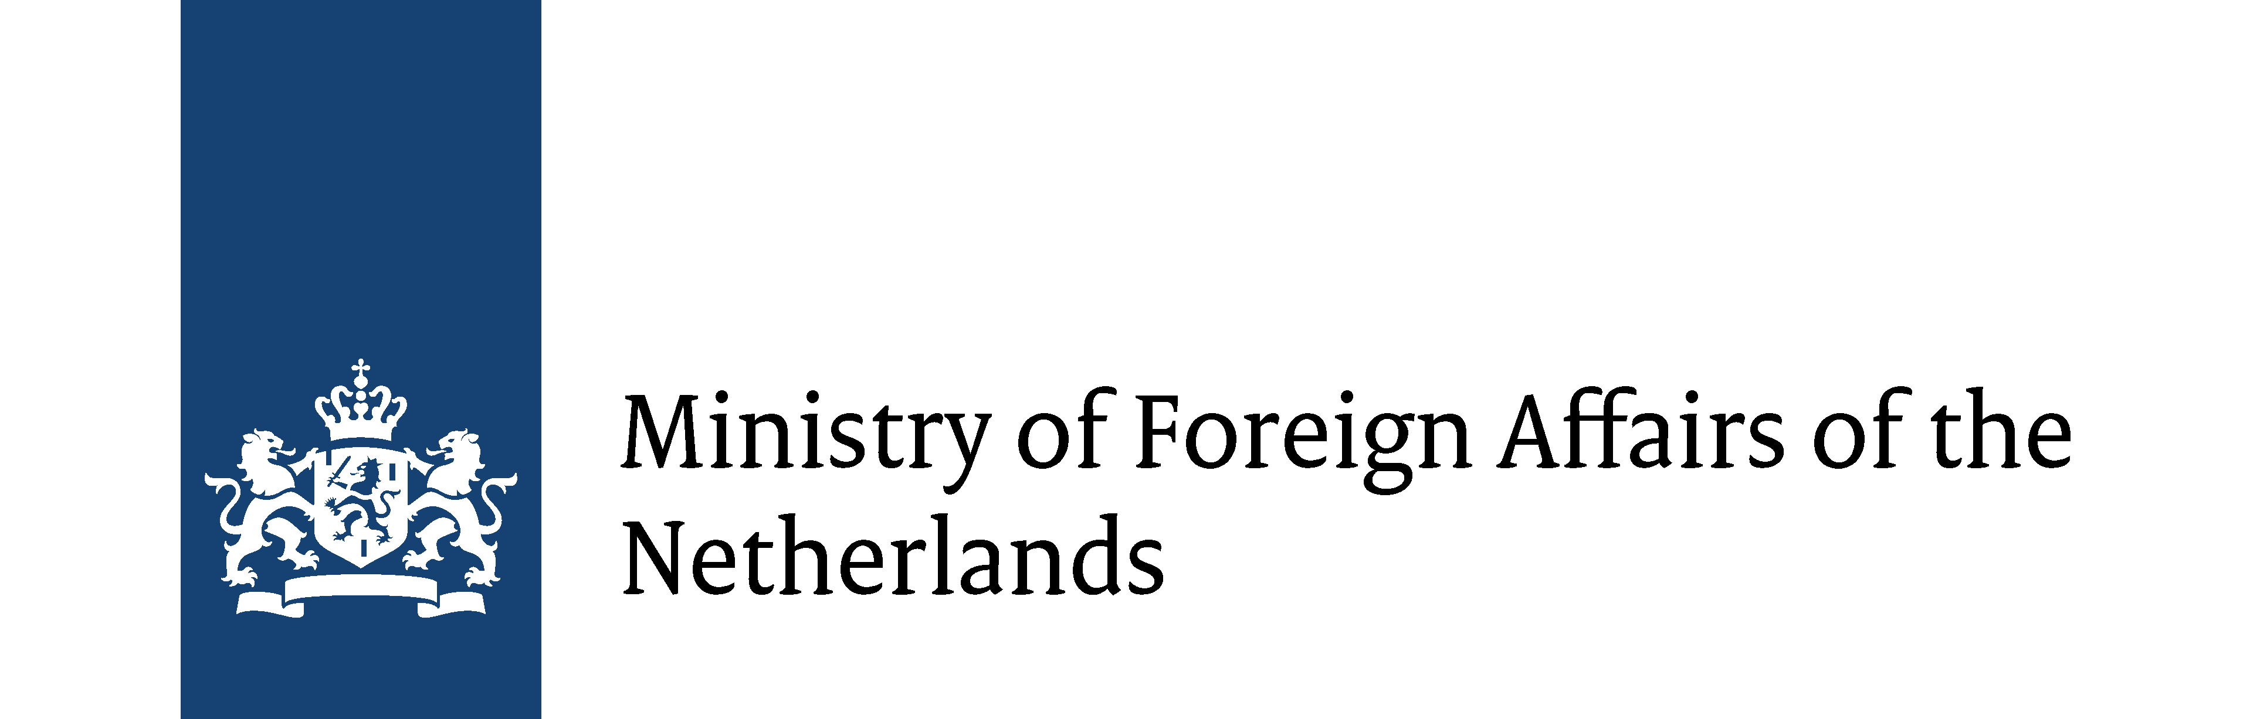 www. oxfamibis.dk

This approach has drawn on the vast experience of feminists and women’s human rights defenders with expertise in SGBV prevention and response worldwide, including multilateral organisations such as UN Women and the World Health Organization
Physical, sexual and psychological violence are some of the common forms of GBV - https://eige.europa.eu/gender-based-violence/what-is-gender-based-violence
Domestic violence involves both intimate partner violence and child abuse: https://apps.who.int/iris/bitstream/handle/10665/77432/WHO_RHR_12.36_eng.pdf;jsessionid=FDEE8F8521C9252A05209EDF573394DA?sequence=1; https://www.unicef.org/media/files/BehindClosedDoors.pdf
https://www.theguardian.com/society/2020/mar/28/lockdowns-world-rise-domestic-violence?CMP=share_btn_fb&fbclid=IwAR3
https://www.unicef.org/guineabissau/press-releases/covid-19-children-heightened-risk-abuse-neglect-exploitation-and-violence-amidst
This will be especially practical if the nature of the incident requires the survivor to be transported urgently, especially after curfew, when there is additional risk to the survivor’s safety.
If GBV Monitors do not have basic training on GBV in particular, virtual training must be provided.
The Interagency Minimum Standards for GBV: https://www.unfpa.org/minimum-standards

